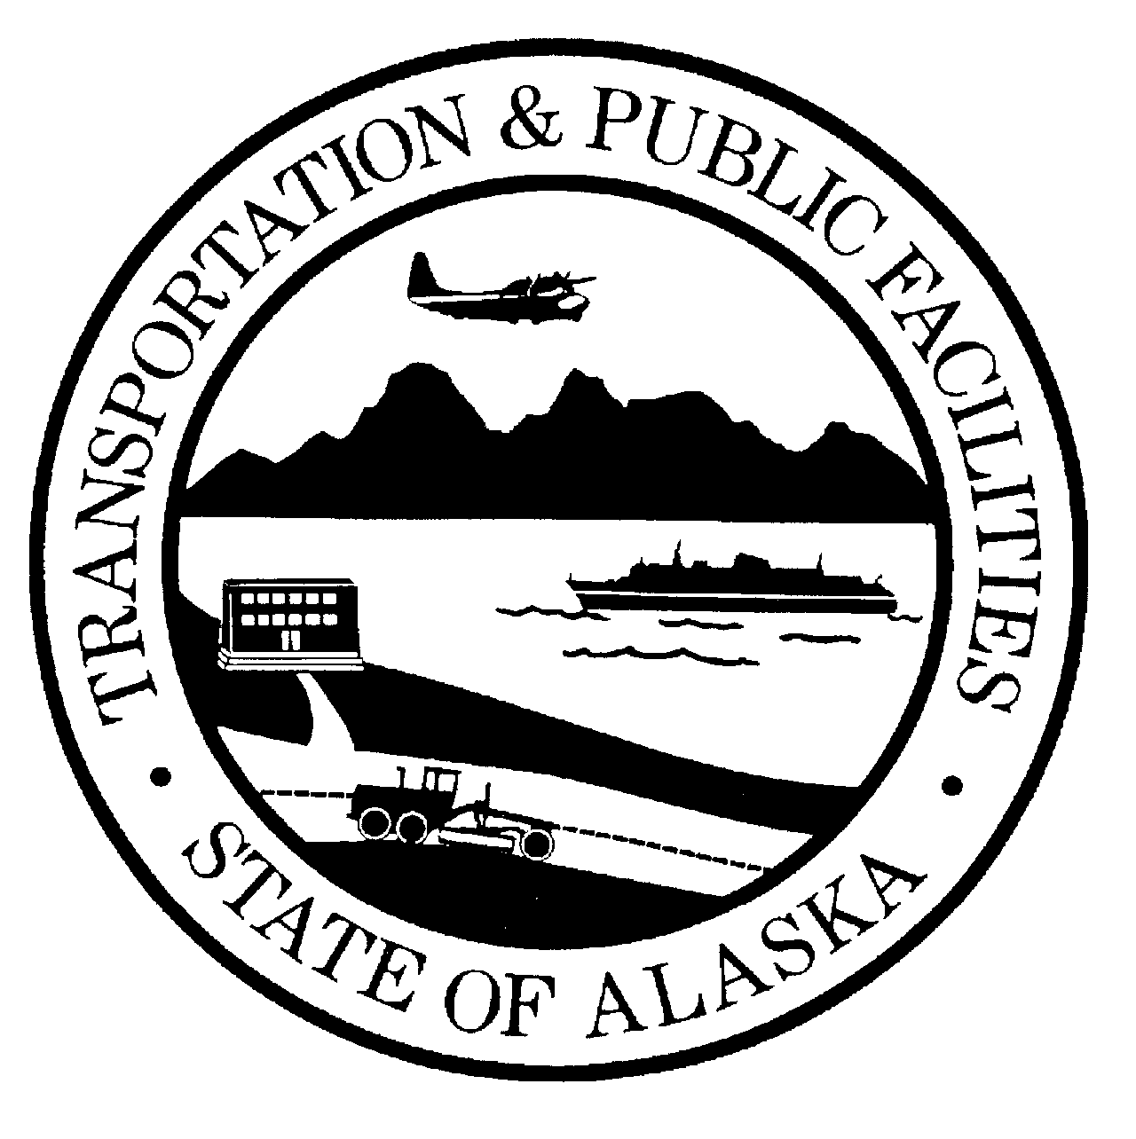 | STATE OF ALASKA  DEPARTMENT OF TRANSPORTATION AND PUBLIC FACILITIES  SUBCONTRACTOR LIST

Project Name and Number

The apparent low bidder shall complete this form and submit it so as to be received by the Contracting Officer prior to the close of business on the fifth working day after receipt of written notice from the Department.
An apparent low bidder who fails to submit a completed Subcontractor List form within the time allowed will be declared nonresponsible and may be required to forfeit the bid security.
Scope of work must be clearly defined. If an item of work is to be performed by more than one firm, indicate the portion or percent of work to be done by each.
Check as applicable: [ ] | All Work on the above-referenced project will be accomplished without subcontracts
 | Or
[ ] | List all first tier Subcontractors as follows:
FIRM NAME,  ADDRESS,  PHONE NO. |  | AK BUSINESS LICENSE NO.,  CONTRACTOR'S  REGISTRATION NO. |  |  | SCOPE OF WORK TO  BE PERFORMED
CONTINUE SUBCONTRACTOR INFORMATION ON REVERSE

For projects with federal-aid funding, I hereby certify Alaska Business Licenses and Contractor Registrations will be valid for all subcontractors prior to award of the subcontract. For projects without federal-aid funding (State funding only), I hereby certify the listed Alaska Business Licenses and Contractor Registrations were valid at the time bids were opened for this project.
Signature of Authorized Company Representative |  |  |  | Title
Company Name |  |  |  | Company Address (Street or PO Box, City, State, Zip)
Date |  |  |  | Phone Number

FIRM NAME,  ADDRESS,  PHONE NO. | AK BUSINESS LICENSE NO.,  CONTRACTOR'S  REGISTRATION NO. | SCOPE OF WORK TO  BE PERFORMED

