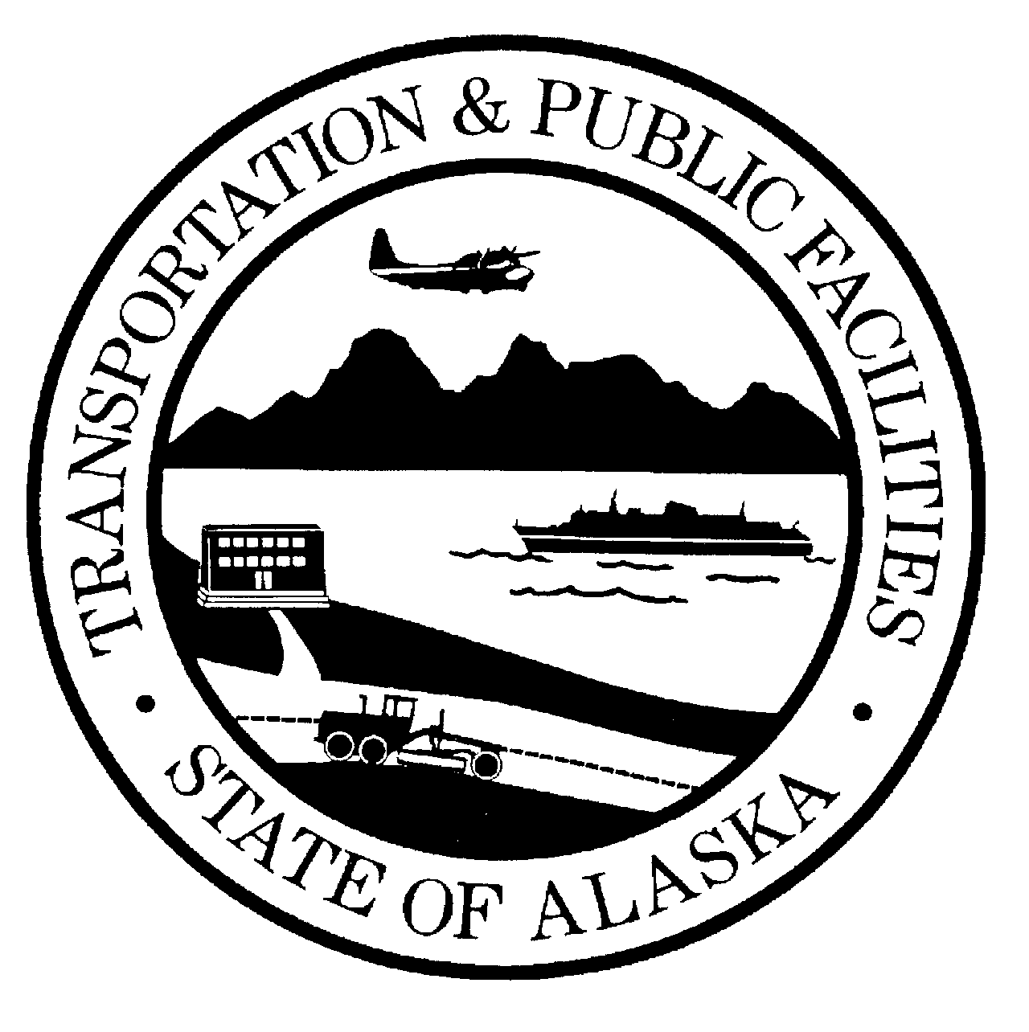 | STATE OF ALASKA  DEPARTMENT OF TRANSPORTATION AND PUBLIC FACILITIES  ALASKA VETERAN PREFERENCE CERTIFICATION

In response to the advertised procurement for:

Project Name and Number ,

Bidder (Contractor)

Operation of Alaska Veteran Preference
Procurement preferences under the Alaska Procurement Code are benefits that the State grants only to qualified bidders. Under AS 36.30.321, an eligible entity receives a five percent preference to the price of in the bidder’s proposal if the bidder meets three requirements.
The bidder must be:
- an “Alaska Veteran”;
- a “Qualifying Entity”; and
- an “Alaska Bidder”.
Unless a bidder satisfies all three requirements and furnishes corresponding certifications, it is not eligible for the Alaska Veteran Preference. This preference may not exceed $5,000.

Instructions regarding Alaska Veteran Preference
A bidder that claims the Alaska Veteran Preference must review and complete the “Alaska Veteran Certification”, the “Qualifying Entity Certification”, and the “Alaska Bidder Certification”. The individual that signs a certification shall include his/her printed name and position within bidder’s organization, e.g., sole proprietor, partner, etc. If a bidder fails to submit properly completed certifications, the Department will not apply the claimed preference.

Alaska Veteran Certification
(To be completed by individual(s) upon whom the bidder relies in claiming the Alaska Veteran status. If bidder is a partnership, limited liability company, or corporation, then a majority of partners, members, or shareholders who are Alaska Veterans must sign this Alaska Veteran Certification for the Bidder to be eligible for this preference.)

I hereby represent to the Department that:

I served in the armed forces of the United States, a reserve unit of the United States armed forces, the Alaska Territorial Guard, the Alaska Army National Guard, the Alaska Air National Guard, or the Alaska Naval Militia; and
I was separated from service under a condition that was not dishonorable; and
I am Alaska resident in that I am physically present in the State of Alaska with the intent to remain in the State indefinitely and to make a home in the State.

I certify under penalty of perjury that the foregoing statements are true and correct as they apply to me.

By (signature) Date

Printed name Title

Qualifying Entity Veteran Certification

The bidding entity for which I am the duly authorized representative is a:

(Check the appropriate box)

- sole proprietorship owned by an Alaska Veteran;
- partnership under AS 32.06 or AS 32.11 and a majority of the partners are Alaska Veterans;
- limited liability company organized under AS 10.50 and a majority of the members are Alaska Veterans; or
- corporation that is wholly owned by individuals and a majority of the individuals are Alaska Veterans.

By applying my signature below, I certify under penalty of perjury that I am the duly appointed representative of this bidder, which has authorized and empowered me to legally bind it concerning the proposal and that the statement I have acknowledged above by checking the appropriate box is true and correct.

By (signature) Date

Printed name Title

Alaska Bidder Certification
(To complete your claim for the Alaska Veteran Preference, you must also submit an Alaska Bidder Certification, which the bidder can view, download, and print from the AKDOT&PF’s Bid Express Proposal page.)

