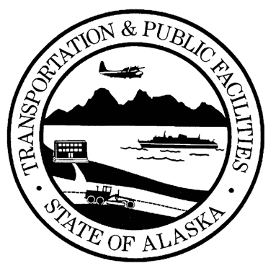
STATE OF ALASKA
DEPARTMENT OF TRANSPORTATION AND PUBLIC FACILITIES

SWPPP CERTIFICATION FOR CONTRACTOR

Project Name:
Operator:

I certify under penalty of law that this document and all attachments were prepared under my direction or supervision in accordance with a system designed to assure that qualified personnel properly gathered and evaluated the information submitted. Based on my inquiry of the person or persons who manage the system, or those persons directly responsible for gathering the information, the information submitted is, to the best of my knowledge and belief, true, accurate, and complete. I am aware that there are significant penalties for submitting false information, including the possibility of fine and imprisonment for knowing violations.

Name:

Duly Authorized Representative in accordance with Appendix A, Part 1.12 APDES
General Permit for Discharges From Large and Small Construction Activities

Title:

Date:

Signature:

