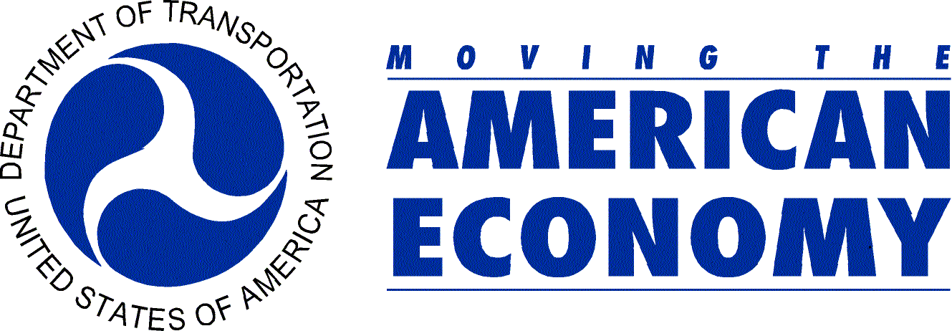 | U.S. Department of Transportation  Office of Public Affairs  Washington, D.C.  www.dot.gov/affairs/briefing.htm

News

DOT | Contact: Sarah Echols
Wednesday, January 30, 2008 | Tel.: (202) 366-4570

Transportation Secretary Peters Announces
New Five Star Rating System for Car Seats

A new five star government rating system will grade child safety seats on how easy they are to properly install, and will help guide parents and caregivers in choosing the right car seat to keep their children safe, U.S. Transportation Secretary Mary E. Peters announced today.

Secretary Peters and National Highway Traffic Safety Administrator Nicole Nason outlined the new star rating system at an Arlington, Va., fire station today, and released new star ratings for 78 child safety seats currently on the market.

“Even the safest car seat can’t protect a child if it isn’t installed correctly,” Secretary Peters said. “These new star ratings arm parents with the best information and challenge manufacturers to make car seats that are easier for parents to use.”
NHTSA data indicates that seven out of 10 child safety seats are either the wrong size for the child or seriously misused, reducing their effectiveness in a crash, Secretary Peters said. When properly used, child restraint systems reduce fatal injury by 71 percent for infants and 54 percent for toddlers in passenger cars, and in light trucks, by 58 percent for infants and 59 percent for toddlers.

Under the new five star ratings, expanded criteria are being used to evaluate child safety seats, Secretary Peters said. The seats are awarded an overall star rating, as well as individual star ratings in four categories: securing the child, vehicle installation features, labeling and instructions. Five stars represent the highest rating and one star signifies the lowest rating.

“These changes will make it easier for consumers to compare products and determine which child safety seat is easiest for their daily routines,” said NHTSA Administrator Nason.

Secretary Peters stressed that the new rating system does not measure how effective a child seat is in protecting a child in the event of a crash, but rather compares how easy one seat is to use over another. All child restraints sold in the United States already are required to comply with federal safety standards to provide a high level of crash protection for children.

The Department will continuously rate new models as they are introduced into the marketplace, she said. A complete list of the new rankings is available at: www.nhtsa.dot.gov

####

